

PSG Management System

User and Administrator Procedures

1. Getting Started 3

1.1. Logon: 3

1.2. Initializing Your User Account 3

1.3. Bulk Sign-Off of System Documents 4

1.4. Changing Your Password 5

1.5. Verify Your Email Address 5

2. Updating User Account Information Quarterly 7

3. Searching for a Document or for Keywords in PSGs 8

4. Requesting a User ID or Password 10

5. Email Notification 11

6. Reviewing and Signing a Document 12

7. Posting a Comment 13

8. Editing in Browser 15

# Getting Started

## Logon:

1. The PSG Management System is a web-enabled application. The URL to login is as follows:

<https://powerdms.com/ui/Login.aspx?SiteID=GTA>

1. Your User ID and initial password will be provided by the GTA site administrator. If you have a problem logging in, send an email explaining your problem to [gtapsg@gta.ga.gov](mailto:gtapsg@gta.ga.gov) and someone will contact you.
2. If you forget your User ID or password, please refer to the Instruction: “Requesting a User ID or Password”.

**Terms of Service:**

Once logged on, depending on your assigned level of access, you may find a Terms of Service Agreement. Please agree to use of powerDMS.

**Understanding Your Homepage (End User):**

After you log in to PSG Management System your screen will show your homepage. The top menu bar is your primary tool for navigating the application. The homepage is your hub and dashboard where you'll begin your navigation every time you log in. Important keys are shown below in the Sample Homepage.



Figure: Sample Homepage

## Initializing Your User Account

There are three tasks to be performed to initialize your User Account:

1. Bulk Sign-Off of System Documents
2. Change Your Password, and
3. Verify Your Email Address

## Bulk Sign-Off of System Documents

Go to *Inbox, Documents*

You may find a message asking you to sign-off on all the documents in your Inbox.

This message provides you a way to confirm your awareness of the Enterprise Information Technology and Security Policies and Standards with one action, rather than signing off on each one.

Entering your User ID and Password provides your confirmation and the documents will leave your Inbox.

You may at any time thereafter search the documents to retrieve any document by topic, keyword or title.

Please note that when new PSGs are placed into the System, you will receive a notice to sign-off on them individually to confirm your awareness.



## Changing Your Password

To change your password, e-mail address, and security questions, hover over *WELCOME Name* at the upper right-hand corner of the screen and click Change Security Settings.



*A Valid Password must contain:*

* *at least 8 characters*
* *at least one number*
* *at least one lowercase letter*
* *at least one uppercase letter*

To change your password, fill in your new one twice, ensuring it meets the listed requirements. Finally, enter your current/old password. Then click Save to retain your changes.

## Verify Your Email Address

The *EMAIL* tab is used to verify and to change your everyday, working email address where you can be contacted. This address will be used to notify you that you have:

* An *Inbox* message,
* New PSGs waiting your confirmation or
* Some other action requiring your attention.

The email notification is for your convenience to keep you from checking the PSG Management System daily. Your notification will look something like this:

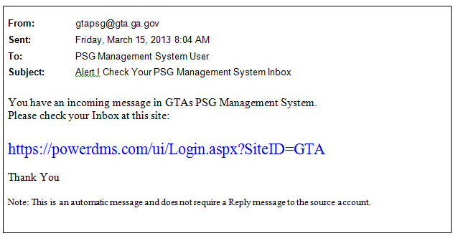

The *SECURITY QUESTIONS* tab captures your answers to specific questions that can be used to help you obtain a new password when/if you forget your current password.

# Updating User Account Information Quarterly

It is important that the PSG Management System to have current agency staffing contact lists and contact information. This information will be maintained on a quarterly basis initiated with an email to Agency CIOs.

Agency CIOs will be asked quarterly to notify the system administrator of personnel changes within their respective organizations who are in positions assigned a user license to the PSG Management System.

At any time, the Agency CIO or an individual may notify the system administrator of a change with an email to:

[gtapsg@gta.ga.gov](mailto:gtapsg@gta.ga.gov).

Note: Individuals should maintain their personal PSG Management System user information when their email address changes.

# Searching for a Document or for Keywords in PSGs

To search the entire site from the top menu bar, just start typing inside the *Search* box – the System

searches all documents, and returns suggestions below the *Search* box as you type.

Once you start typing, a list of eligible items will appear. In the sample below, a user is interested in PSGs that relate to or include the keyword “net”. Note that these three letters returned a list of 10 policies and standards that contain the three letters. The more complete the search keyword/search term is typed, the more accurate the return list will be.

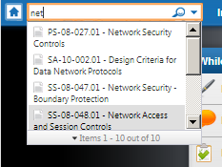

Simply click a title to open the item.

You can search by full or partial PSG number, or by the complete title of a PSG.

If an item you’re trying to locate doesn’t appear when you’re finished typing in your keyword/search term, click the magnifying-glass icon within the *Search* box to conduct a more in-depth search. The PSG Management System will return search results by relevancy:

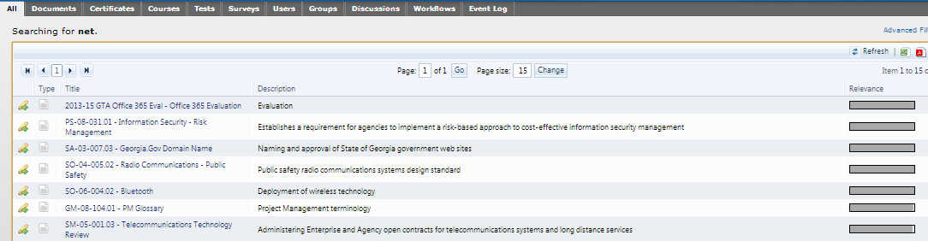

You can also click among the top tabs to narrow down your search results by item type – document, certificate, etc.

A list of searchable items also appears when you hover over the arrow on the *Search* box on your top

menu bar- documents, users, groups, certificates, etc. Clicking any item type will take you to its separate search tab, where you can search strictly for that item using Advanced Filters. Simply fill in your search criteria and click Search to locate the item you need!

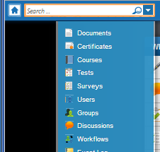

You may then click on the Home Page icon at any time to return to the Inbox or other action.

Click on the *logoff* icon, located on the extreme top right of the screen, to leave the system. See below:



# Requesting a User ID or Password

If you forgot your User ID:

1. Send an email requesting your USER ID to the system administrator at [gtapsg@gta.ga.gov](mailto:gtapsg@gta.ga.gov). Identify yourself – name, agency etc. The system administrator can look up your User ID and email it back. Also, the system administrator will reset your password and notify you of the new password, as well. Please change your password during your first visit to the system

If you forgot your password:

1. Go to the system logon block (URL: <https://powerdms.com/ui/Login.aspx?SiteID=GTA> )
2. Click on “Forgot Password?”

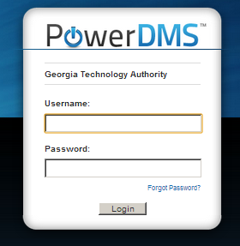

1. You panel shown below will be returned. Fill in the requested information and a password will be sent to your email account.

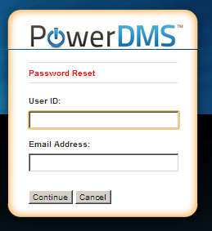

# Email Notification

This Instruction provides guidance for your actions when you receive this notification by email.



1. Logon to the PSG Management System at the link shown in the email.
2. Open your *Inbox* and select a waiting document or message.



1. Perform the action indicated by the appropriate Instruction Page below:
   1. *Signing a Document*
   2. *Reviewing a Document*

# Reviewing and Signing a Document

To take action on a document you're asked to review or sign, click ***Inbox*** on the top menu bar, which will take you straight to your inbox’s *Documents* tab.

The action expected of you is indicated as “*Task: Sign*” or “Task: Review”. Both actions are similar. Click on the document name and review it. Make sure to check the “Discuss” feature to review prior comments and add your own if you desire. Then provide the appropriate response – approve, deny, thumbs up, thumbs down etc.

1. Open *Inbox – Documents.* Then Open the desired document by clicking on the document name. In the example, you would click on *“PM-13-002”* to open that document’s viewing page.

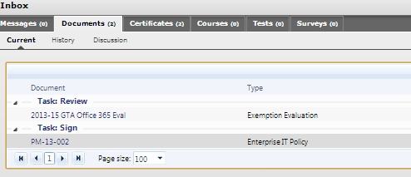

1. Review.
2. When you’re ready, enter your username and password at the bottom-right-hand corner of the page, then click Sign. Note, if the signature blocks has the format of a thumbs up/down, merely click the appropriate icon.

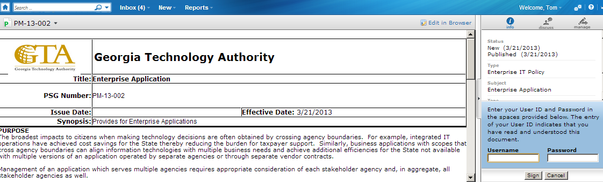

1. You may then click on the Home Page icon, return to the Inbox or other action. Click on the *logoff* icon, located on the extreme top right of the screen, to leave the system. See below:



# Posting a Comment

During the creation of a new PSG or when processing an exemption, an SME or a Manager may ask a question of other participants or merely post a comment from the Document View in powerDMS.

The upper right of the information panel shows several Icons. The *Discuss* icon will open the comment capabilities. One can view prior comments and post comments by clicking the icon. The image below is the Information Panel with various action buttons.

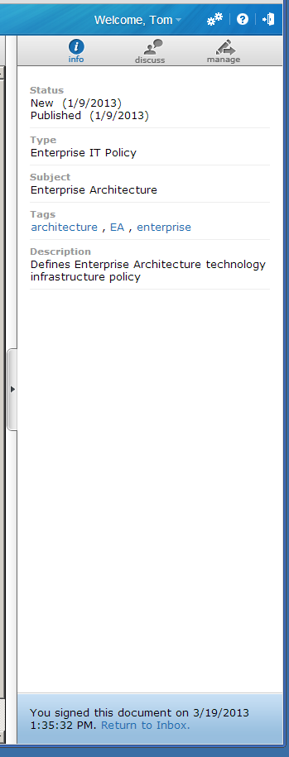

When *Discuss* is opened, the comment dialog is shown. By clicking *Add Comment* at the bottom of the information panel, one can enter a new comment.

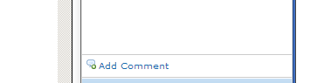

The above image is the view prior to clicking on “Add Comment”.

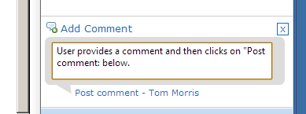

The above image is the view after clicking on “Add Comment” and after typing a comment. Click on “Post Comment” to save the comment on screen.

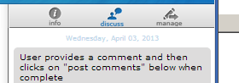

The above image shows a posted comment.

# Editing in Browser

SME’s working on a new PSG or Exemption Evaluation and select GTA Managers will have the ability to edit documents. To tell if you have this ability, look for the words “Edit in Browser” in the upper right hand corner of the Document View Panel.

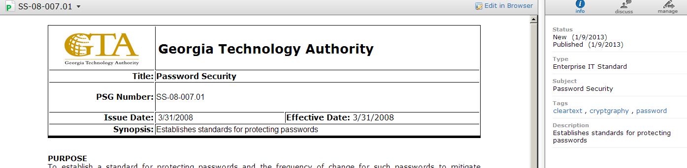

Click on the words “Edit in Browser” and click “OK” to the message that notifies you that “Modifying the active file on a published revision is not recommended. Are you sure you wish to continue?” The Document Panel now shows edit tool bar at the top.

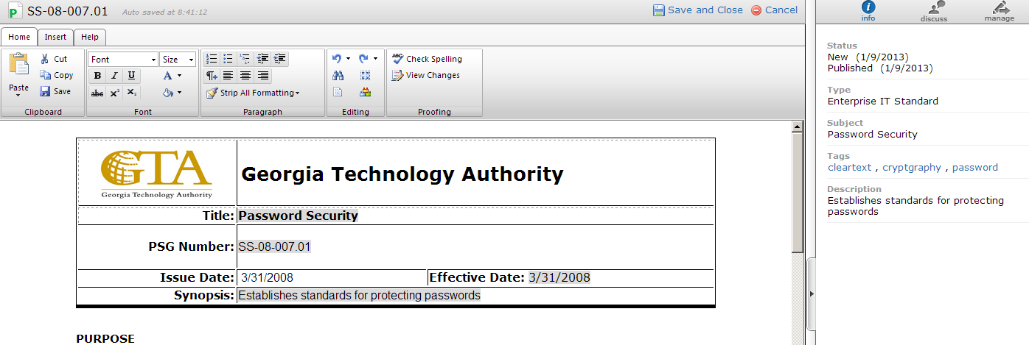

You will find that the tools are not as expansive as found in native Microsoft Word, but usable. The image below explains some of the functions of the Home Tab tool bar.



The image below explains some of the functions of the Insert Tab tool bar.



When you finished with editing, click either “Save and Close” or “Cancel”.